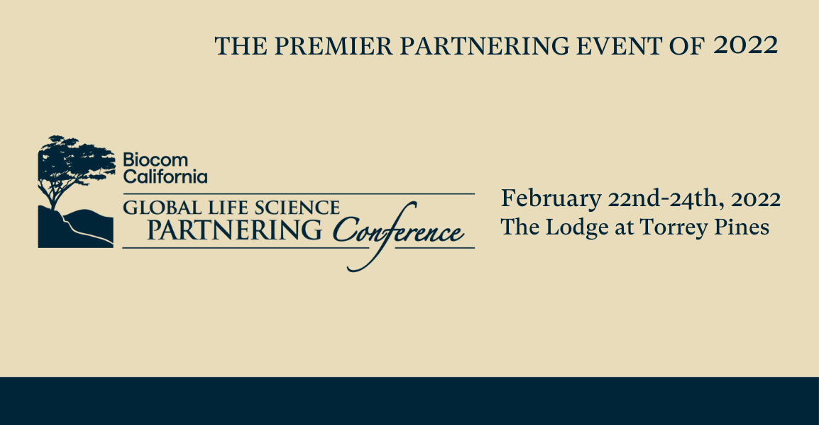

2022 Company Presentation Application – Biocom Global Life Science Partnering Conference

Date:
Company Name:
Company Presenter:
Contact Name/Email:
Contact Phone: | / /
Company Address:

Company Information
Therapeutic area: |  |  |  | Public or Private status
Date of incorporation: |  |  | Number of Employees:
Highlights (both recent, anticipated & milestones):

Corporate Mission:

Proprietary Technology:

Current Alliances:

IP Status:

Commercialization and/or Partnering Strategy:

Financing Strategy (including details of the most recent completed round):

Products (Name, Indication, Phase, Milestone): |  | Product Name: |  |  | Indication: | Phase: |  | Milestone:
Investors (including each investors stake): |  | Name:
*Senior Management: |  | Name: |  |  |  | Position:
*Board of Directors: |  | Name: |  |  |  | Company:

* Highly recommended that you also provide a link to a corporate website and slide deck for additional info.
Please email the completed application to Ashleigh Farver at afarver@biocom.org.
Upon submission, your application will be submitted to the Conference Selection Committee for review.
The presentation fee is $1000
Please note: If accepted, this does not waive your registration fee. In addition to the presentation fee, all attendees are required to register for the conference.

